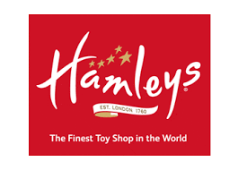 

**Project Implementation Report**

Business Intelligence & Business Analytics

MSc Data Analytics (Group B)

**HARSH CHUDASAMA(18187340)**

**PALAK(18185461)**

**RAJA PUNIA(18185746)**

**ANIMESH KUMAR(18184731)**

School of Computing

National College of Ireland

Supervisor: Mr. Vikas Sahni

**Contents**

­­

**1. Introduction 2**

**2. Porter’s Five Force Model 2**

**3. Balanced Score Card 4**

**4. Opportunity pipeline management 6**

**5. PDCA 8**

**5.1. Plan 9**

**5.2. Do 10**

**5.3. Check 11**

**5.4. Act 11**

**6. Supply Chain Management: 11**

**7. B-web 13**

**8. Implementation in Dynamics CRM 13**

**9. Implementation in Power BI 19**

# Introduction

We have discussed different models and frameworks below on which our solution is dependent on, considering the data of Hamleys for the prospect of sales inflation.

# Porter’s Five Force Model

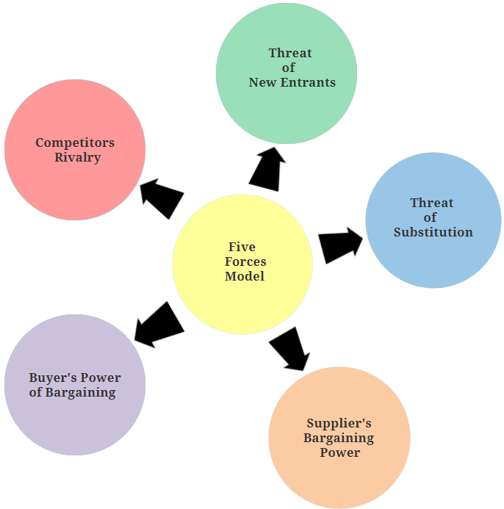

Figure 1: Porter's Five Force Model

Porter’s Five Force enables the business heads to introspect the competition level in their domain[1]. Maintaining profitability becomes essential with increase in competitions. That is where the Porter’s Five Force Model comes into play. It consists of 5 forces, two of which relate to the Vertical participants (Supplier and Consumer) while the other three relate to Industry participants.

1. **Threat of new entrants**

This refers to the level of ease that a new entrant might/might not experience while entering the market. Greater the ease, greater is the competition.

For centuries now, Hamleys has a monopoly in the toy market. One of the major reasons for a threat that might arrive for Hamleys is cost/price of products. A toy company focusing on all classes of the society might/might not possess threat to Hamleys in future.

1. **Competitors Rivalry**

This factor considers the number of competitors and the activity of company’s rivals.

It has competitors like Toys R Us, Rob Roy Toy Makers, Harrods, FirstCry and others but none hold as much power as Hamleys as of now.

1. **Threat of substitution**

This covers the possibility of a new good or service harbouring the current market and affecting the company’s sales.

Although nothing replaces the good old authentic toys, Hamleys still might fear a threat of being substituted by technologies. Mobile phones, Tablets, PCs and other electronics pose a threat since all the traditional games can easily be played on device these days.

1. **Supplier’s Bargaining Power**

This establishes the hold of a certain supplier on the cost and profits of a product based on the availability of a supplier.

Hamleys association with Lego could be taken as an example here. Lego has an ascertained power over Hamleys for the products it provides.

1. **Buyer’s Bargaining Power**

A customer possesses the power of driving prices lower or higher according to their preference and number.

Hamleys target audience could influence the inflation and deflation of prices, products or profits of the company.

# Balanced Score Card

The balanced scorecard is a model which is used in a business to evaluate and balances its measures of financial performance, customer satisfaction, internal operations and learning and growth. If an organisation wants to stay in competition in business market, its employees should as the questions which are in balanced scorecard again and again until the main objective of the organisation is not met. It is a visual framework that helps organizations to translates strategy into operational objectives that drive both behaviour and performance.

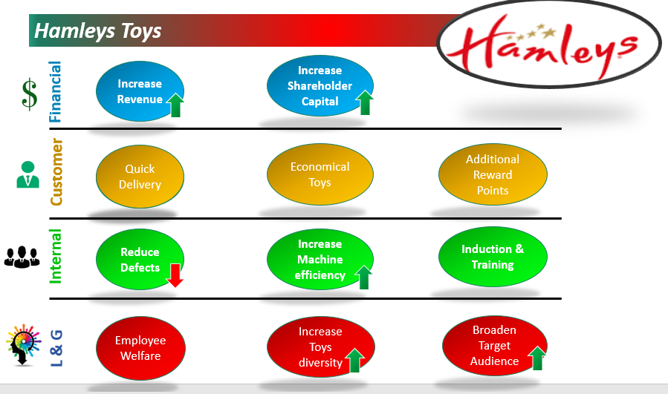

Figure 2: Balance Scorecard

Hamleys BSC: In balanced score card there are four perspectives which are on the vertical side of the strategy map.

these four parameters are:

* Financial Perspective
* Customer satisfaction,
* Internal Operation Perspective and
* Learning and growth Perspective

Balance score card is a complete performance measurement tool which defines all the necessary strategies required in the business to grow.

Its performance report is based on all required measurements which are financial and non-financial.

1. **Financial perspective**

**Goals**

* Increase shareholders wealth
* Increase Profit Margin
* Increase revenue

**Measures**

* Cost management
* Financial Ratios
* Profit growth 25%
* Sales growth 30%

1. **Customer satisfaction perspective**

**Goals**

* Customer Satisfaction
* After Sale services to retain customer
* Market Penetration

**Measures**

* Customer retunes and complaints.
* Quick delivery
* Economical toys
* Additional reward points
* Customer satisfaction surveys.
* Coverage and strength of distribution channel.

1. **Internal operations perspective**

**Goals**

* Reduce Number of defects
* amount of rework
* number of returns.
* Increase machine efficiency.

**Measures**

* Innovations
* Research & Development
* Training to employees

1. **LEARNING AND GROWTH PERSPECTIVE:**

**Goals**

* Increase Number of new economical toys.
* Increase R & D output success rate.
* Employee turnover, number of complaints.
* Employee satisfaction and retention.
* Increase toys diversity
* Broaden target audience

**Measures**

* Increase Number of training hours.
* Introduce New Technology
* Employee Welfare

**Summary**

This Balance score card will help Hamleys to grow and master the knowledge skills and management that employees will need **(learning and growth)** to innovate, create and embrace the right strategic abilities and efficiencies **(internal process)**that will give us the result we are seeking for our business **(customer)** which will lead us the eventual result we need **(financial)** i.e. increase shareholders wealth and increase firm’s revenue.

# Opportunity pipeline management

It is a method to easily and effectively organize, manage and track your business opportunities.

A pipeline has multiple action plans that can lead to the successful close of an opportunity. It is a visual representation of where the prospects are in the deal process in CRM. If you can find out how to turn the leads into opportunities and close the deal, then you will be successful in your job.

We have taken our leads from the customers in the feedback form. We asked customers to tell us if they are not buying products from here then from which store, they would like to buy it. By doing this, we will collect the information about that in our database and target those stores to acquire them. Our aim is to acquire the retail shops to expand our business. retail shops are our leads. We will create the leads in CRM and will move step by step until we close the deal.

Below is the data we got from the customers feedback. And it shows the pipeline management flow of CRM.

It consists of 5 processes namely Opportunity, contacts made, property visited, proposal presented and close as won.

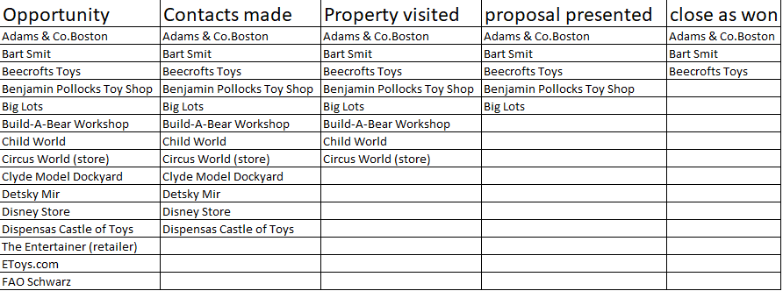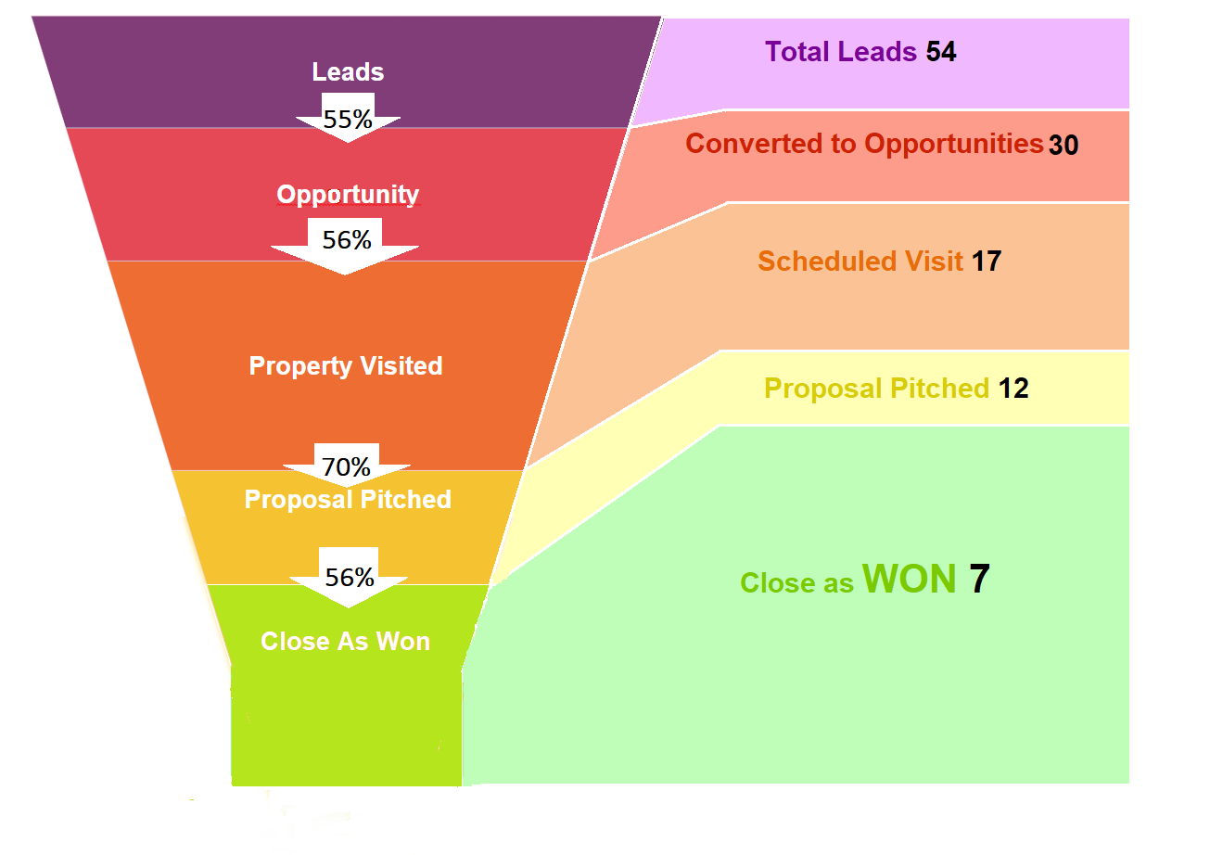

Figure 3: CRM Pipeline

Figure 4: CRM Pipeline Data view

From the database, we have collected around 54 leads or retail shops from the customers. Now we will try to contact these leads and convert them into our contacts.

As we tried to contact them only 30 of them responded to us. Therefore only 30 contacts were made successfully. Now we will move forward with our contacts and visit them to make a deal with them.

To make our deal we tried to visit these stores. unfortunately, we could visit only 17 leads and rest were not reachable. Out of these 17, only 12 agreed to see our proposal. So, we presented our proposal to them and only 7 agreed to close the deal with us.

Hence, we successfully acquired 7 leads out of 54 with our pipeline model. Which tells us that if we need to acquire 7 leads, we should collect at least 54 of them. If we need to acquire 14 leads, we need to collect 108 leads in our database and so on.

The reps of managers should update the pipeline regularly. Because when leads are added, leads move quickly from one to next stage and deals are closed. All the details should be up to date on every single lead by adding regular notes and information on each step.

# PDCA

PDCA is a continuous improvement plan.  It’s essentially a feedback loop of improvement. Plan, do, check and act are the main perspectives of this plan.

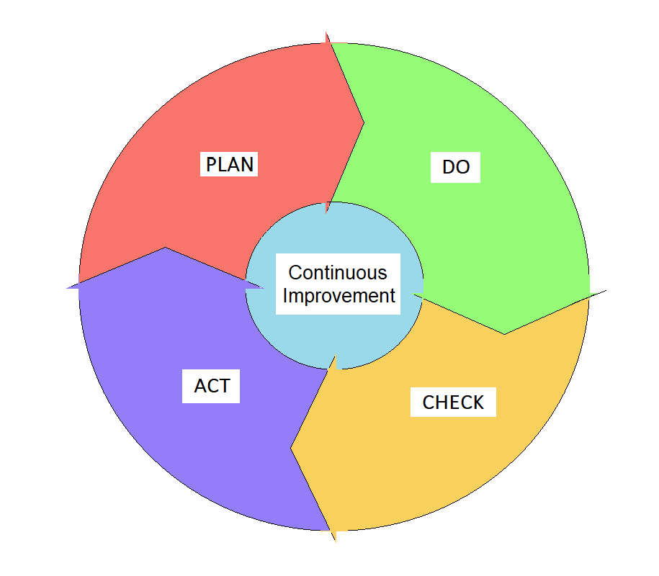

Figure 5: PDCA Cycle

There are 2 common use-cases for PDCA:

**Problem-Solving** – when the business model is not working and broke down. Then PDCA can be used find out the issues of business downfall and to get the new solution for the it.

**Process Improvement** – PDA can be used to improve the existing model if it is not functioning as it should be.

## Plan

We need to find out the exact issues before we introduce new model.

Let’s find out why our sales are down and so that we can get an idea where our current model is lagging and what we should include in our improvement model.

**Why are the sales down?**

* Because we are not targeting the majority of customers. We are restricted only to high society customers.
* Reason could be the lack of economical products in our stores.
* Sales team not giving enough attention to the promotional offers which should be given to customers to retain them.

Aforementioned points are the major reasons for the downfall of the sales.

We must come up with improvement plans to tackle these reasons.

1. We will provide customers loyalty cards and they will be rewarded for each purchase.
2. If customers don’t have loyalty cards, they can opt for it. If customers are not interested in loyalty card, then we can offer then lucrative offers to retain them.
3. We will take feedback from the customers if we need any improvement in our products. feedback forms will be saved in our database and will be routed to higher level management for the approval.
4. We will take survey from the customers if they are not willing to buy product from Hamleys then from which retail shop they would like to buy it, so that we can create a lead for those retail shops and plan to target them.

We have created a workflow according to new plans we have made.

Figure 6: Flow Diagram

## Do

We have decided to go with the new plan we have come up with.

This should, however, be on a small-scale. You can’t know for sure whether your fix is going to be successful and running it company-wide can be extremely risky. We will test our model for 10 days across all our stores. We will give 10% discount to the customers who will buy using our loyalty cards.

For the feedback form we will ask customers to give us feedback of their experience. The feedback will be saved in our database and a case will be created for that customer. The case will then go to the sales team who will check the case thoroughly and if the feedback is rationale then they will act on it and send the case to the management team. If sales team decides not to forward with that case, then they will close the case right then and update the customer as well. After sales team the case will go to the management team and if they agreed with the sales team on the feedback then they will forward the case to the supplier, if not then they will close the case. Supplier will get the consent with the manufacturer and then they will update the support team for the changes to implement.

## Check

Now that we have empirical data on how well our new process works, we can benchmark it to the old. After implementing the plan for 10 days, we will compare the sales with the old plan’s sale. We will see if our new model has generated any growth in revenue. If our new plan works well with the organisation, we will implement it globally.

## Act

We can finally start applying the solution company-wide. We will consider, though, that PDCA is a loop, not a one-time initiative. We can train our employees and management with the new plan and how to implement it at our stores world-wide.

# Supply Chain Management:

Supply chain management is the method of organising flow of goods and services from source to destination. It also includes processing of all the raw materials into final product.

SCM is the methodology to make the supply of goods and its tranformation as economical and efficient as possible.[2] Leakage of consignment in between transportation of goods from source to destination makes it evident to set up a tracking systems for all the goods. RFID (Radio Frequency Identification Code ) and UPC (Universal Punching Codes) are the modern day tracking system, through which we can keep eye of the movement of all the goods.

Figure 7: Supply Chain Management

SCM flow diagram explains that after manufacturing, products get categorised and UP code gets punched over the product, to keep track of that product, before sending to the vendor/supplier.

# B-web

B-web or Business web explains the digitalisation of entire business process from top manufacturing unit to the end user. It suggests replacing all the connection between different units like supplier, retailer with electronic devices and internet so as to produce values for end users.[3]

We are using same in our logistics and inventory processes using radio frequency identification code (RFID) and universal punching code (UPC). This helps in tracking each product at different stages of product lifecycle.

# Implementation in Dynamics CRM

We would be implementing our solution using Dynamics CRM to enable easy connection with various entities present in our system.

The following is a summarisation of our implementation in Dynamics CRM: -

**Objects**: We are accommodating several Objects and Entities in our CRM system. They are briefly described as follows: -

* **Leads**

For the ease of visualising, we’ve imported data for 54 leads that were received from the Customer Feedback form. These leads are considered as the local toy retailers that Hamleys is interested in acquiring.

* **Suppliers**

Our solution includes the Suppliers as Accounts in Dynamics CRM. We’ve imported csv data for 1000 dummy suppliers across the globe.

* **Retailers**

Retailers have been inserted into the system as Contacts.

* **Customer**

Customer has been created as a custom entity in our CRM system to record customer data, especially the feedbacks provided.

* **Employee**

Employee is introduced as a custom entity in Dynamics which would be treated as user or a team.

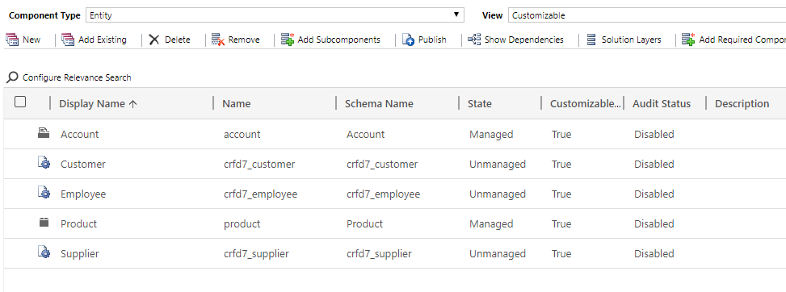

Figure 8: Entities in CRM

**Custom Fields**: Apart from the multiple fields provided by default in Dynamics, our solution required creation of custom fields as well for depiction of processes clearly. Following are the custom fields added: -

1. **Feedback**

A feedback field is added in the customer entity to record the feedback responses by the customer which could be further carried forward till the higher management for suggestions and improvements.

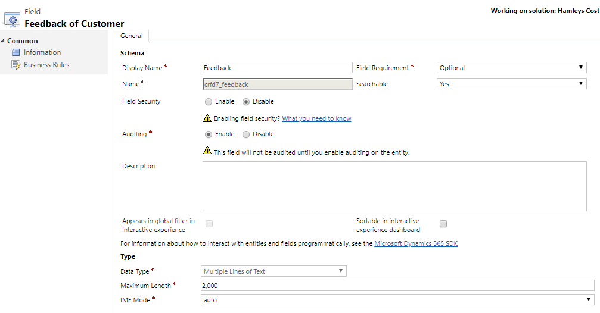

Figure 9: Feedback field in Customer entity

1. **Response**

A response field is integrated in the Supplier entity to record Suppliers agreement or disagreement over a customer suggestion or request after being approved by the management.

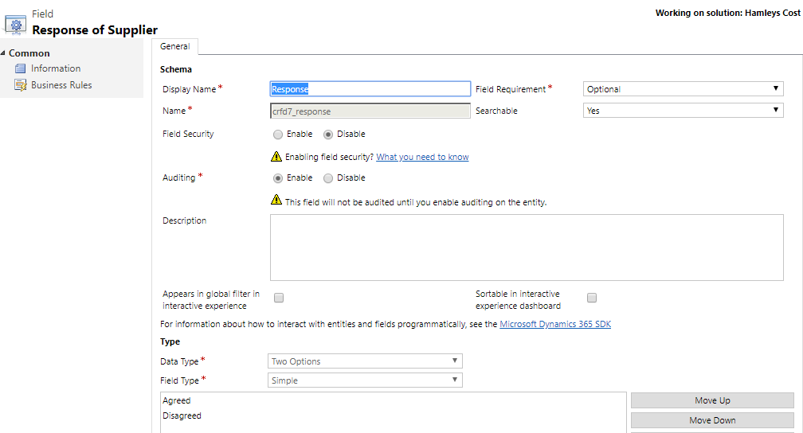

**Relationships**: We’ve defined certain relationships in CRM to establish connection between various entities.

1. **Customer and Vendor**: Customer and Vendor possess a many to many relationships meaning many customers can buy from multiple vendors.
2. **Employee and Customer**: Employee and Customer showcase One to Many relationship meaning an Employee can have multiple Customers but a Customer would bill from a single employee.
3. **Customer and Product**: Customer and Product has Many to Many relationship which means that multiple customers can buy multiple products.
4. **Product and Supplier**: Product and Supplier possess Many to Many relationship meaning multiple products can be supplied by multiple suppliers.

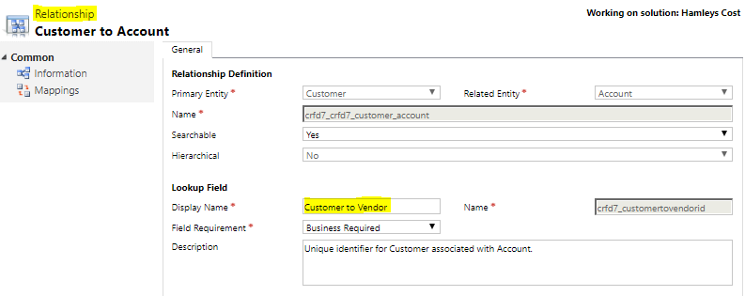

**Validation Rules**: Our solution includes some basic Validation rules classified based on ‘Business Required’ and ‘Business Recommended’. In addition to the existing validations in Dynamics CRM, we’ve following basic rules: -

1. **Business Recommended**: Product field in the Customer entity and Product field in the Supplier entity.

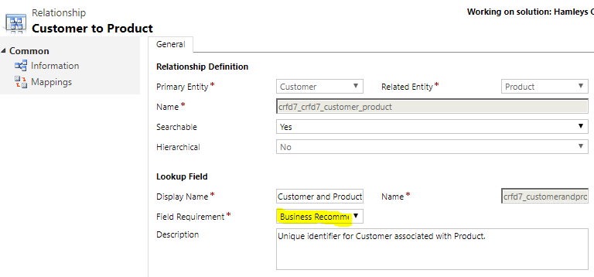

1. **Business Required:** Vendor field in the Customer entity and Employee field in the Customer entity.

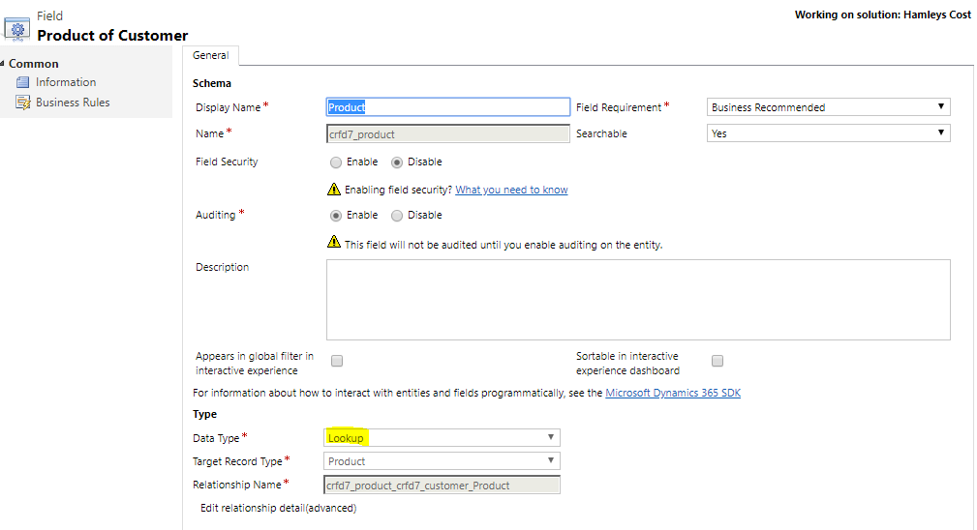**Lookups**: Our Solution includes a custom lookup field on Customer with Product.

**Filters**: We’ve created a customised filter view for the Suppliers who agreed on collaborating with Hamleys.

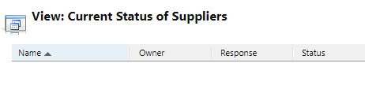

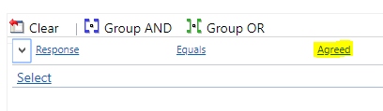

**Processes and Routing Rule Sets**: We’ve implemented certain processes and routing rule sets to implement the process flows in our CRM system.

**Process Triggers** – Our solution focuses on continuous customer involvement, thereby, including communication via mail at almost every step of the process.

* Customers are notified if their feedback has been converted to a case.
* Customers are notified if there is any change or update in the case.
* Customers are notified about the outcome of the feedback.
* Customers with no loyalty cards are made aware of the benefits of attaining the card and other exciting offers.

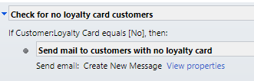

**Process Routing**- Our solution involves automated routing of the Case among various teams.

* At the time of creation of the case by the Support team, the case is assigned to the Sales team automatically if the case ‘type’ is ‘Request’.
* Further, if the Sales associate reports and resolves the case, it is routed to the Management to seek their approval.
* The respective supplier will then receive mail if the Request is approved by the Management.
* Supplier is then provided the option of agreeing or disagreeing after which it would be routed to the teams accordingly. If supplier agrees, Support team is involved in the process again to make any changes in the system related to the product or feedback.

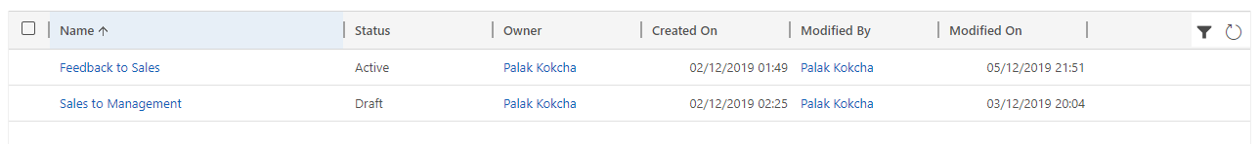

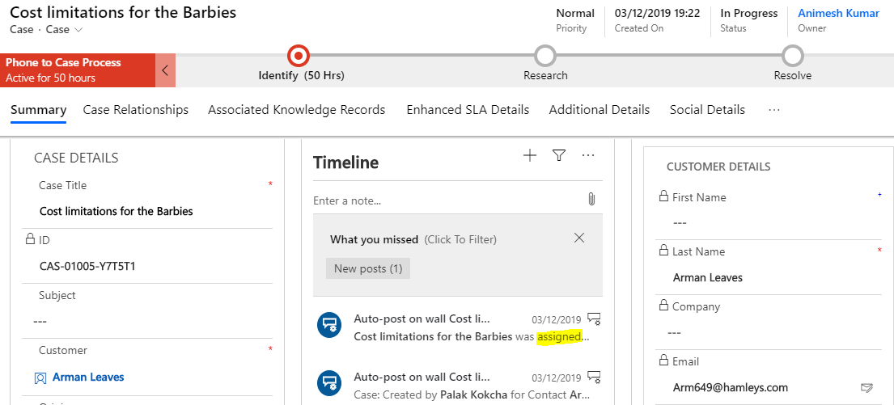

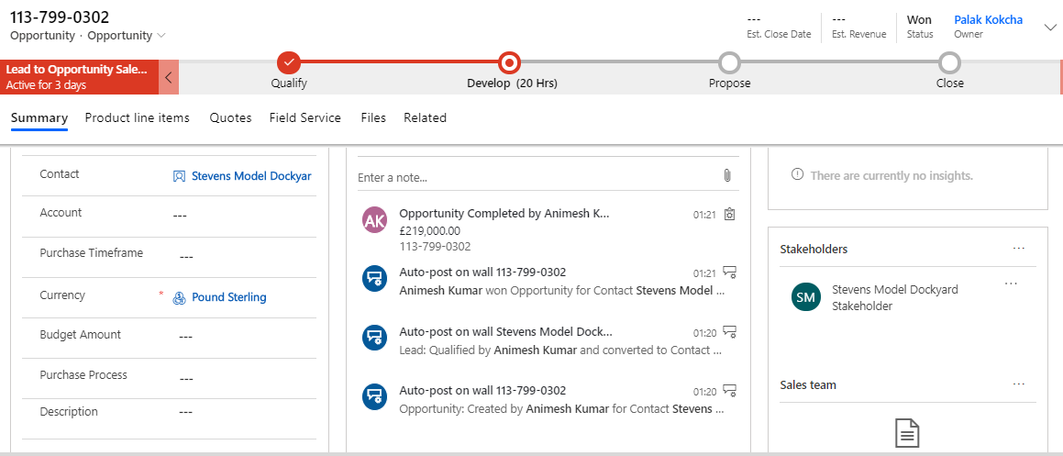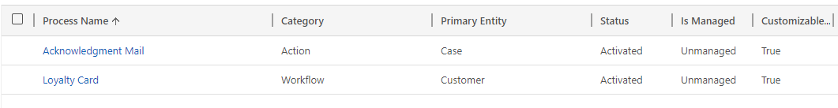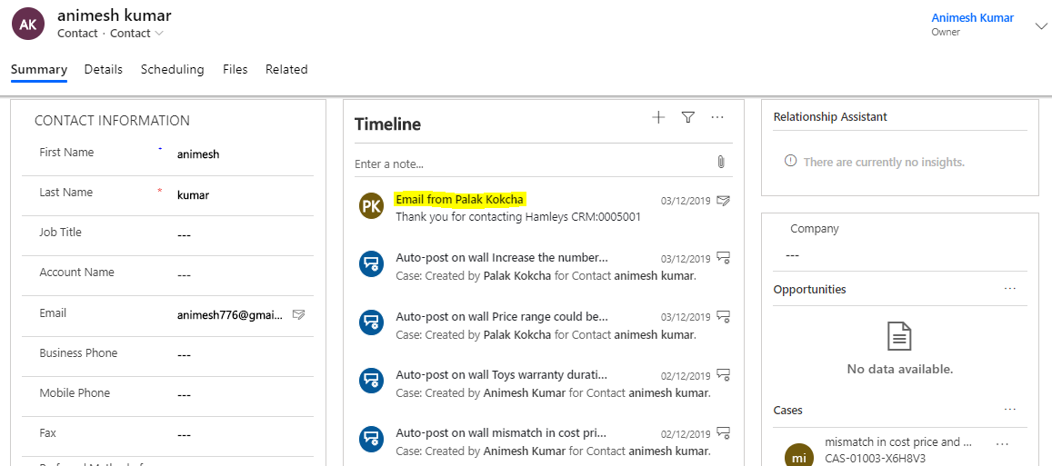

# Implementation in Power BI

Figure 10: Power BI Dashboard

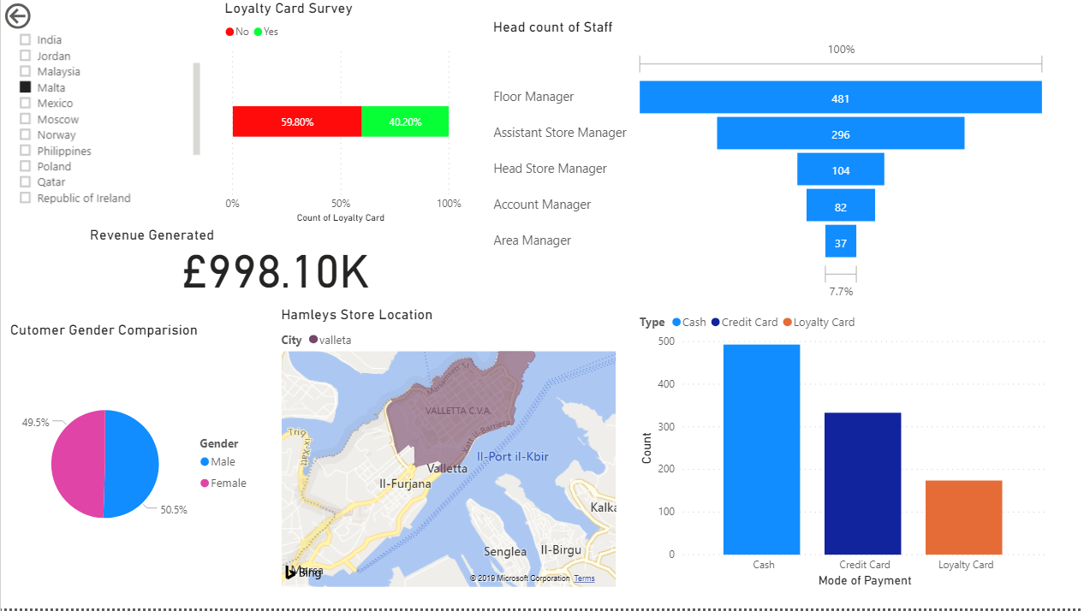This is the Main Dashboard which depicts dynamic customer data that is being populated from Database tables loaded in Power BI Tool. It has following Components:

* **Country** – List of All Stores widespread throughout the globe (You can select multiple Country as well)
* **City** – Location of Store in particular City displayed in map
* **Revenue Generated** – This entity displays record based on Amount fetched from Revenue Table
* **Head Count of Staff** – This field displays the count of Employees located based on Country selected. They have different hierarchy based on Job Roles i.e. Floor Manager being lowest and Area Manager being highest position
* **Mode of Payment**– It displays count of transaction based on ***Category (Cash, Credit Card, Loyalty Card)***
* **Loyalty Card Survey *–*** This Survey shows the data whether customer has Loyalty Card or not. If No, then promotional SMS and Emails will be sent to get Target Customer via dynamic CRM.

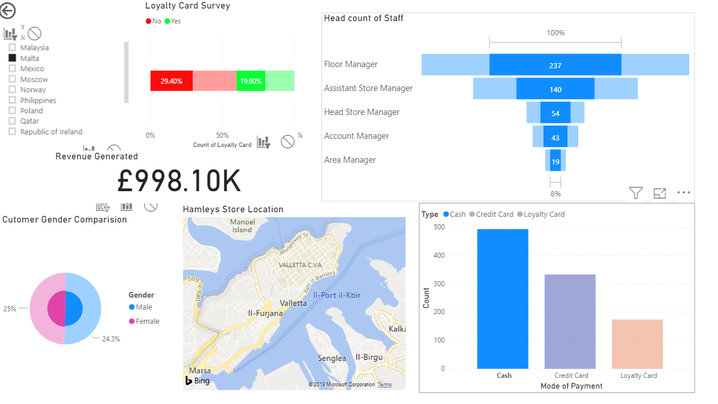For following example: Based on **Mode of Payment – Cash,** Dashboard will be modified as per selection.

Following Views are prepared to visualize data based on specific segment:

1. 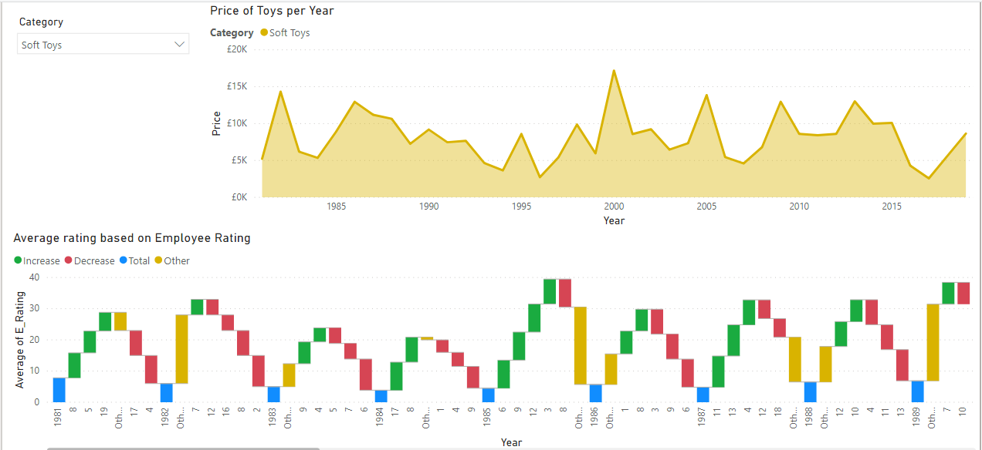**Sales Descriptive:**

Figure 11 Sales Descriptive Report

**Stacked Area Chart**

This graph on top shows trend of Total Product sold based on Toy Category selected:

* Preschool
* Soft Toys
* Arts and Crafts
* Dolls
* Build it
* Action Toys

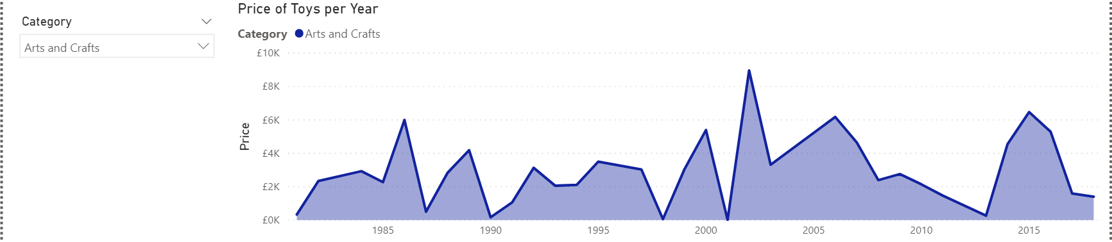

Figure 12 Price of Toys per year

**Waterfall Chart**

This graph is a waterfall chart where Average rating of Employee is based on quantity sold by Employees.

Here, we check Increase and decrease in rating by Employees.

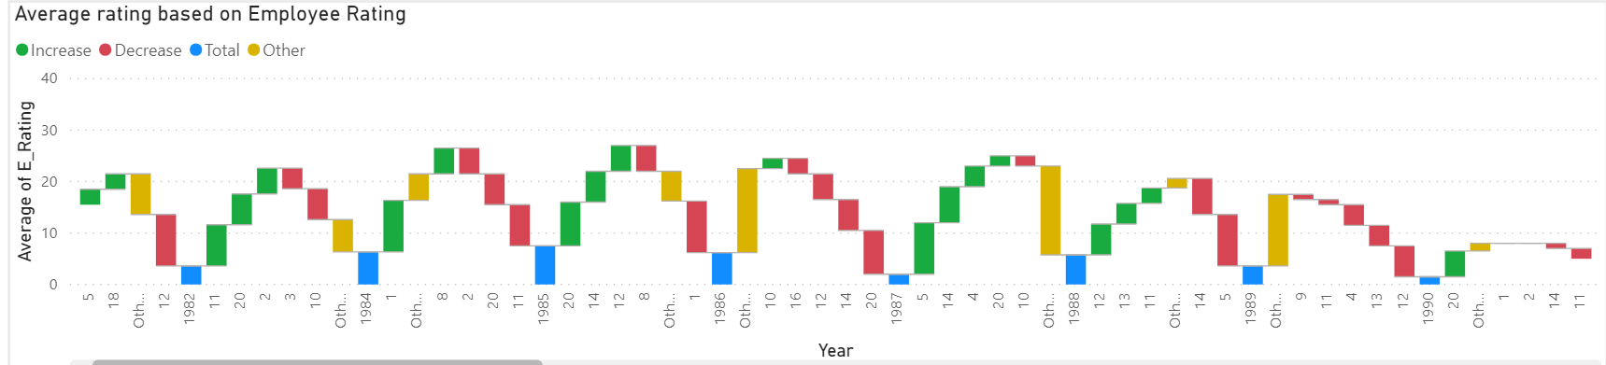

Figure 13 Average Rating based on Employee Report

**Trend Analysis**

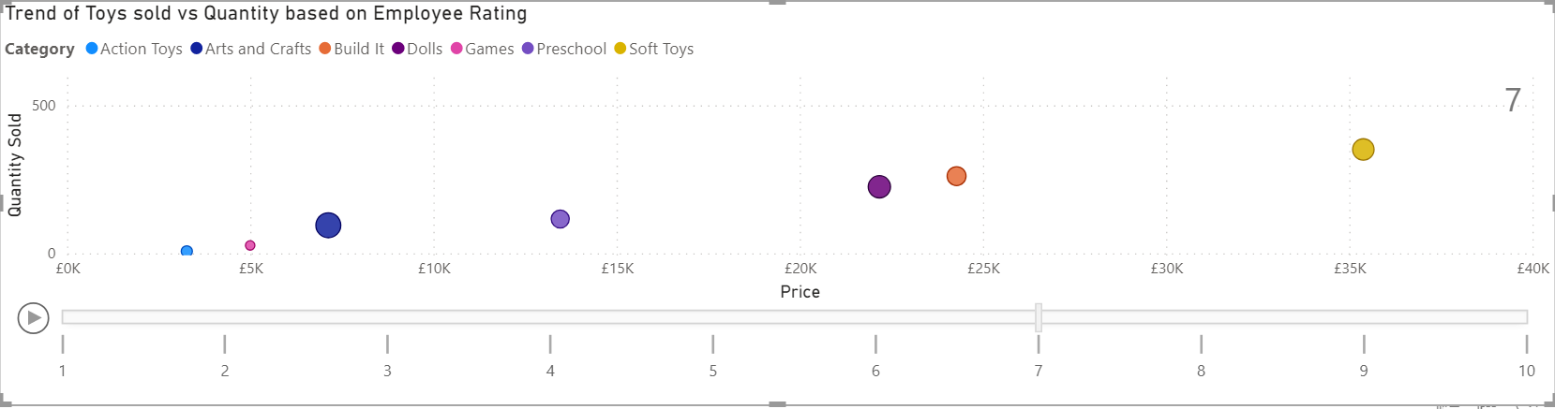**Real time scatterplot:** This graph is a real time scatterplot of Toys Sold by Employees based on Employee rating and distinguished by Category of toys. This is a video graph which goes from 1 to 10 rating.

Figure 14 Trend of Toys vs Quantity based on Employee Rating Report

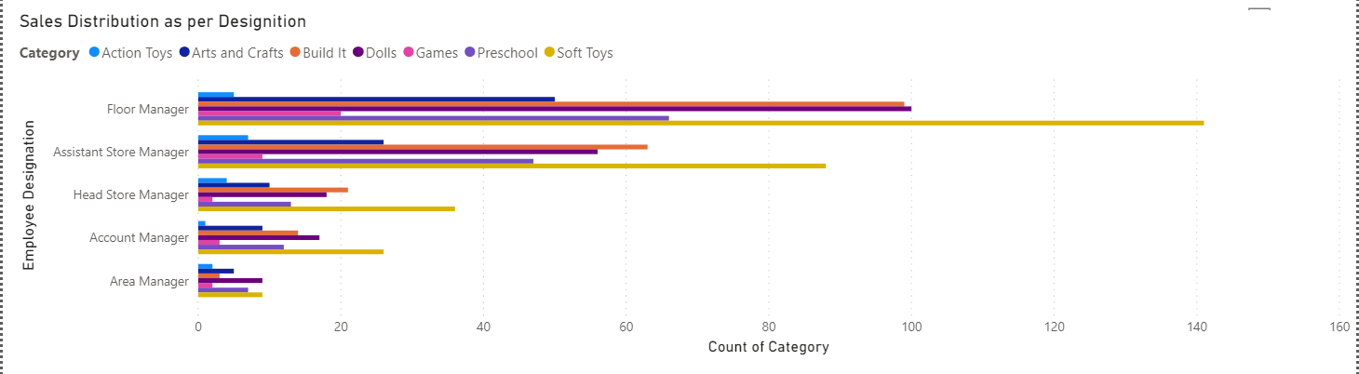**Clustered Bar Chart:**

Figure 15 Sales Distribution as per Designition

This graph shows the sales distribution by Designation based on Toys category with Floor Manager being lowest and Area Manager highest in hierarchy.

1. **Customer Feedback**

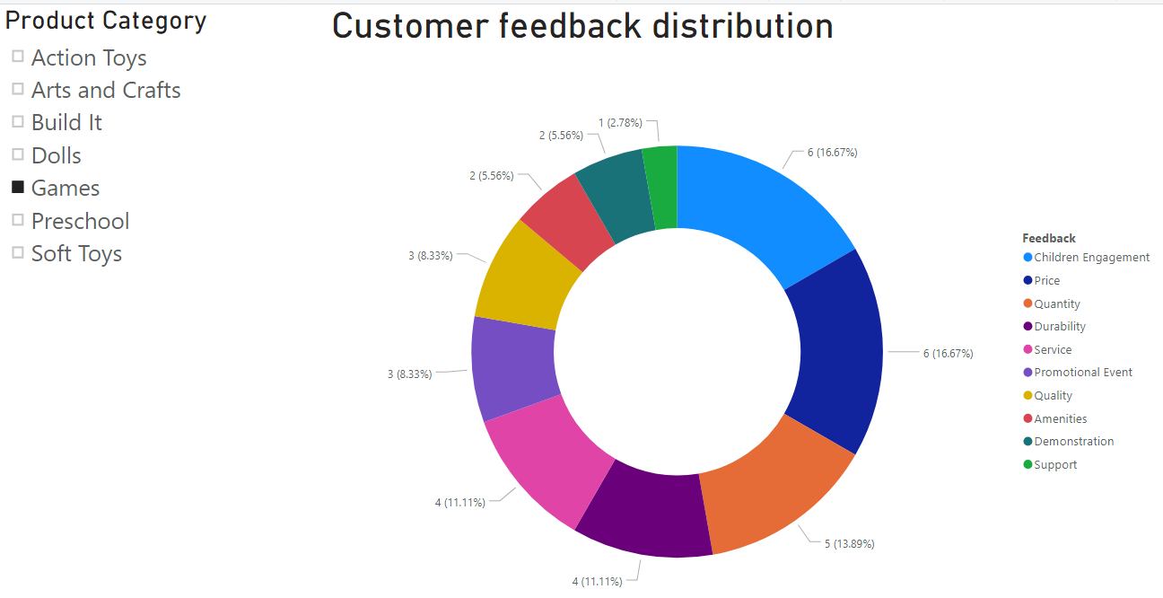**Donut Chart:**

Figure 16 Customer Feedback distribution Report

Following graph is used to capture Feedback of Customer based on Product Categories recorded for improvement program.

Looking at the view, For Games Category, Children Engagement and Price has most count (16.7%).

1. **Word Cloud**

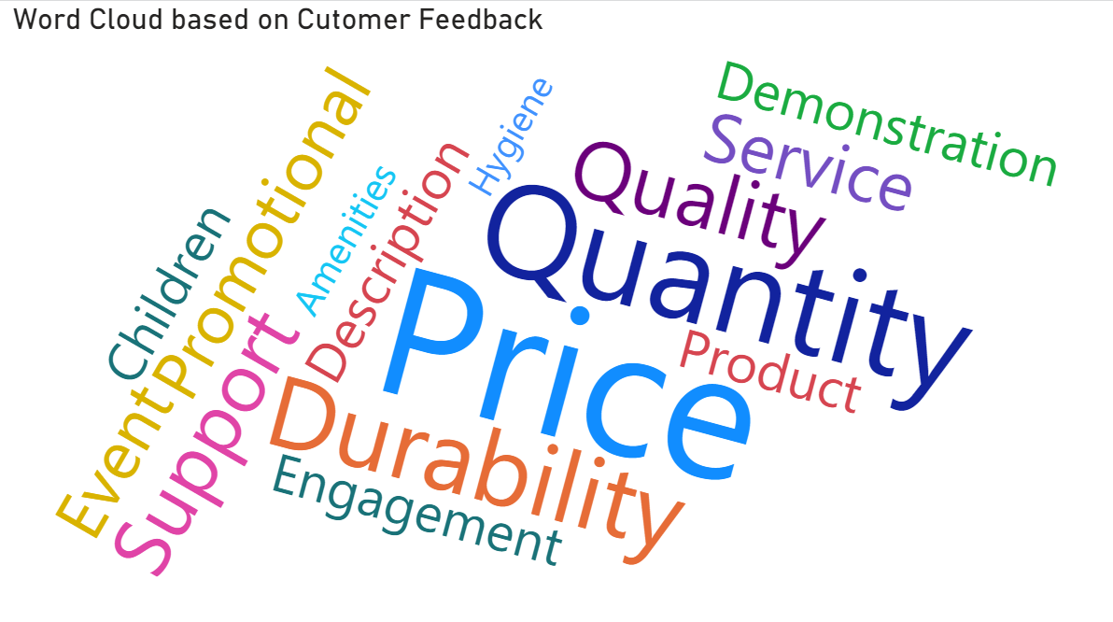

Figure 17 Text Analysis on Customer Feedback

This is Word Cloud is used for text analysis which records the Most Feedback given by Customer.

In this case, **Price** is Most common issue which we are focussing followed by Quantity and so on.

# References

[1] “Porter’s 5 Forces Definition.” [Online]. Available: https://www.investopedia.com/terms/p/porter.asp. [Accessed: 07-Dec-2019].

[2] “Supply Chain Management (SCM) Definition.” [Online]. Available: https://www.investopedia.com/terms/s/scm.asp. [Accessed: 07-Dec-2019].

[3] “The rise of business webs.” [Online]. Available: https://ubiquity.acm.org/article.cfm?id=334434. [Accessed: 07-Dec-2019].